**PROJECT REPORT WEB DESIGNING**

**Name -SMRITI TRIPATHI**

**UID-24BCA10647**

**SECTION-24BCA-08B**

**SUBJECT-WEB DESIGNING**

**Project Title: Amazon Clone Web Design Project Report**

**Technologies used: HTML, CSS, JAVA SCRIPT**

**Live link:**

**Abstract:** The Amazon Clone Web Design Project is a front-end replica of the Amazon e-commerce platform, developed using HTML, CSS, and JavaScript. The aim of this project is to understand and demonstrate essential web development skills by designing a user-friendly and visually appealing website that simulates the look and feel of Amazon's homepage and core functionalities. The project focuses on layout design, responsive styling, and basic interactivity, offering a real-world scenario for applying theoretical knowledge in web development.

**Project Objectives:**

1. To design a visually engaging and fully responsive e-commerce website layout.
2. To replicate the user interface of the Amazon homepage including navigation bar, product listings, and footer.
3. To enhance user experience through interactive features using JavaScript.
4. To understand and apply best practices of front-end development.
5. To gain hands-on experience in building real-world web applications.

**Technologies Implemented:**

* **HTML5:** For structuring the content and layout of the website.
* **CSS3:** For styling the web pages and implementing responsive designs.
* **JavaScript:** For adding dynamic and interactive functionalities like sliders, dropdowns, and product interactivity.

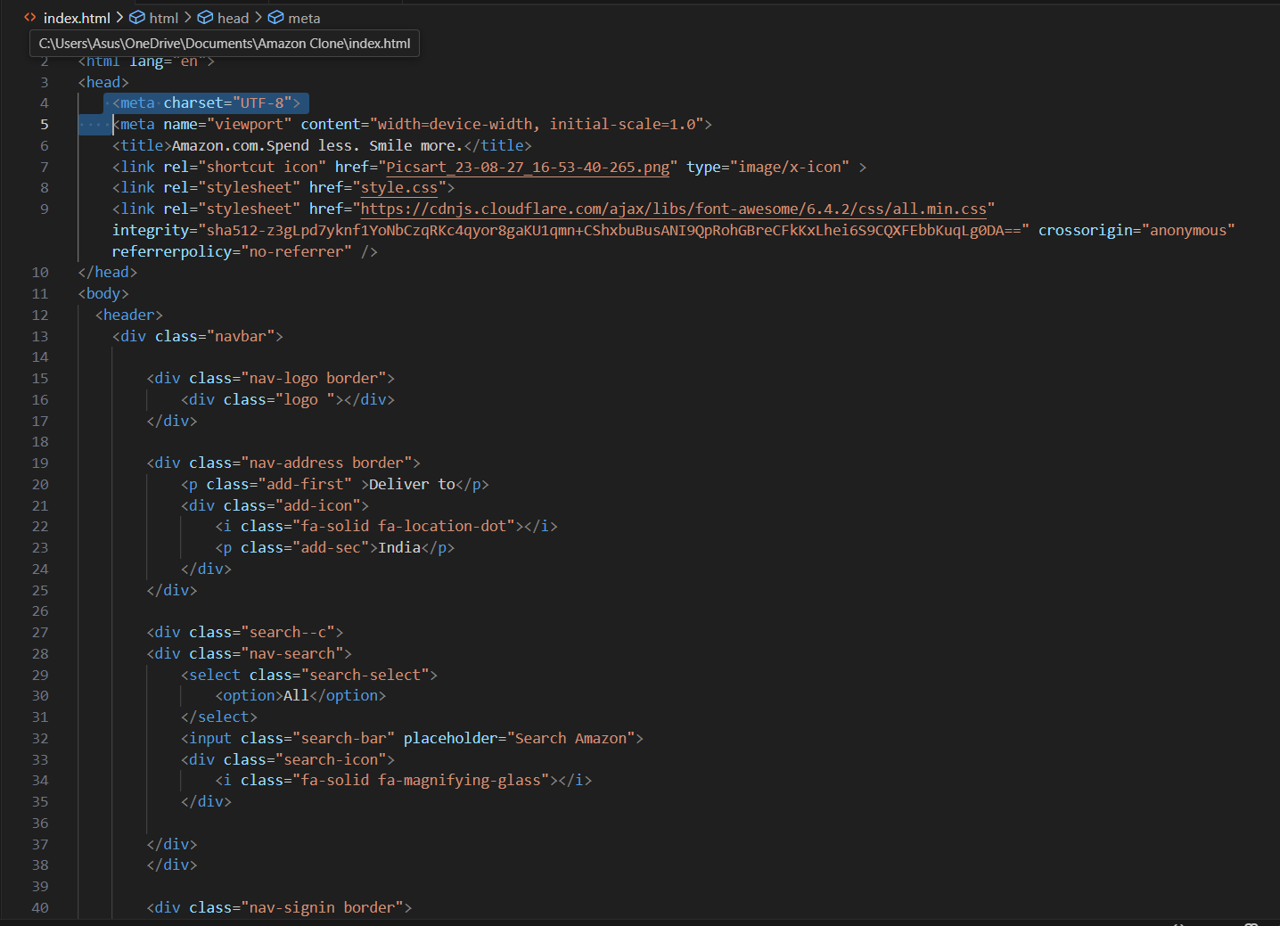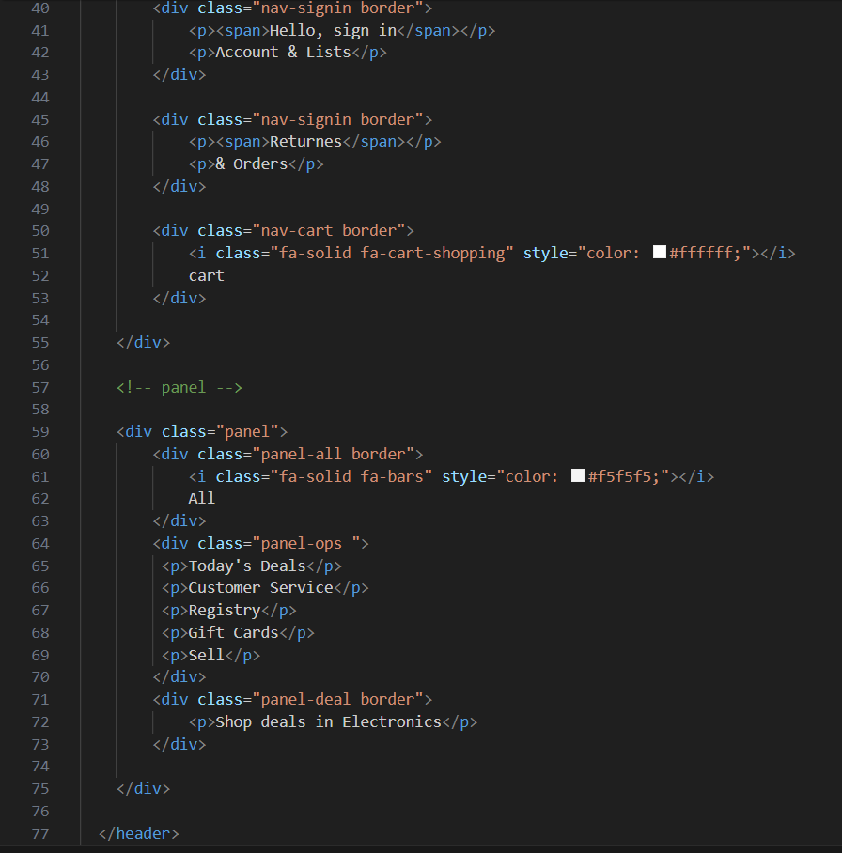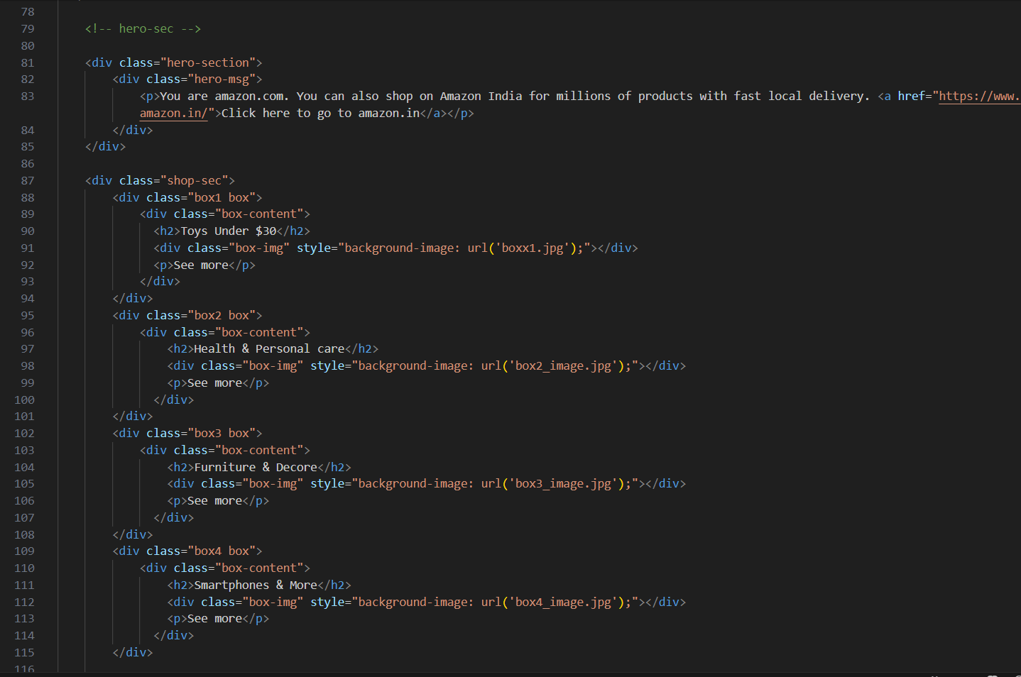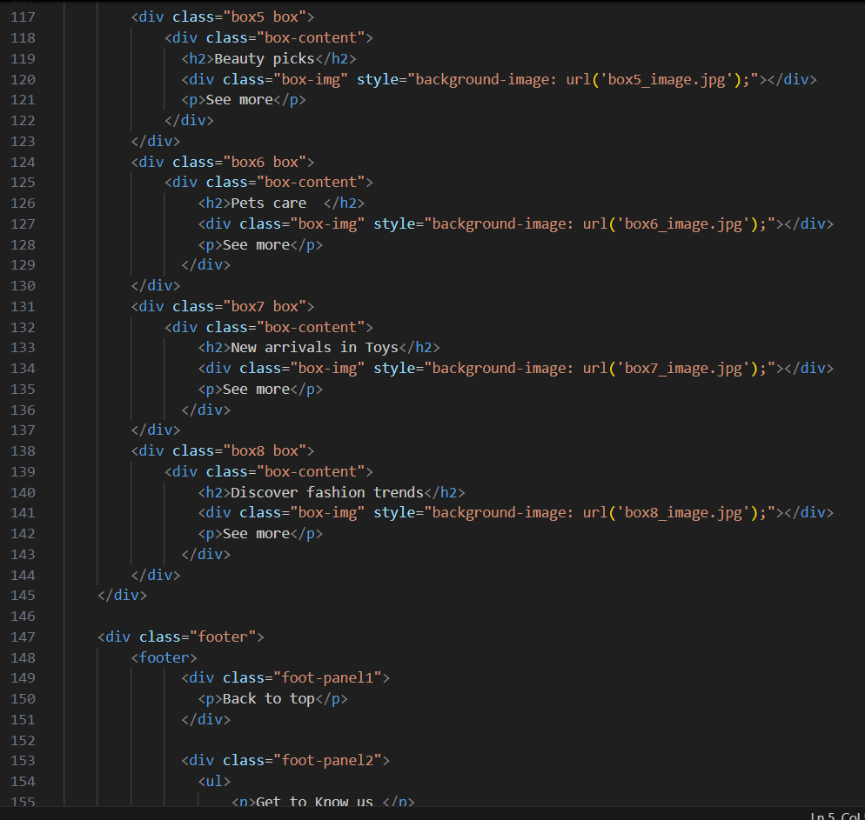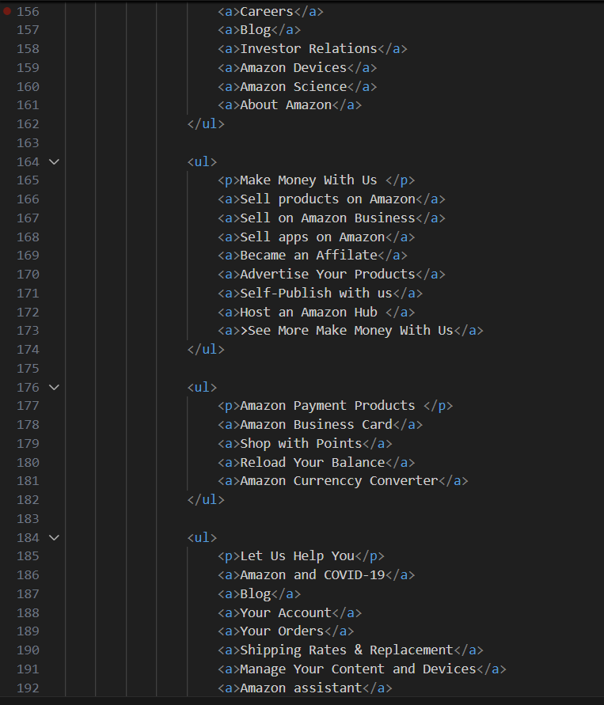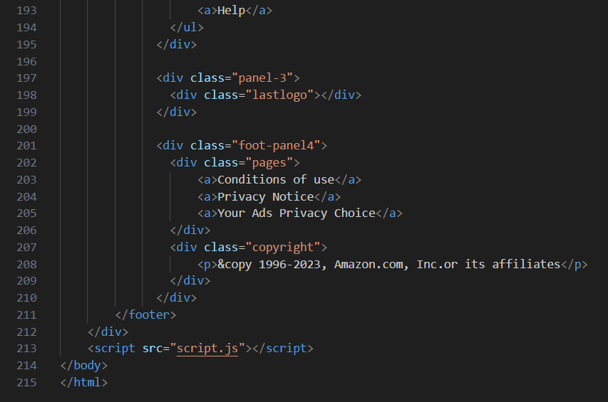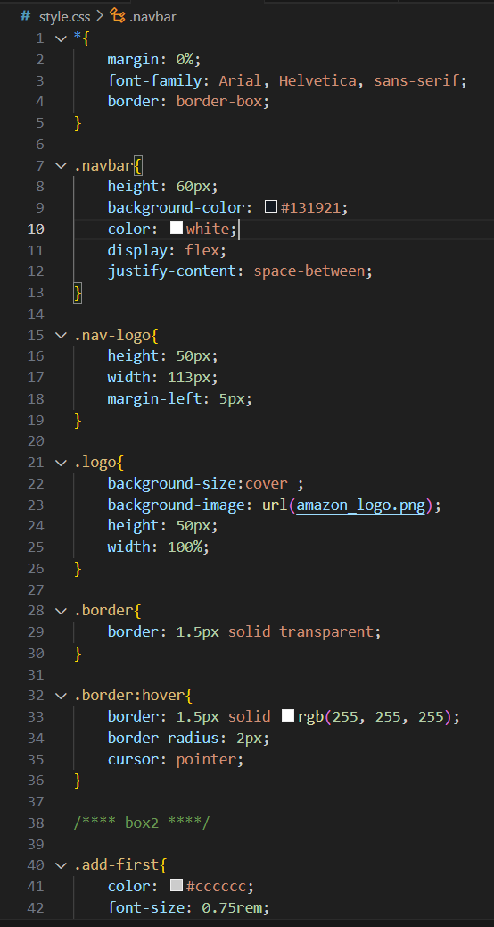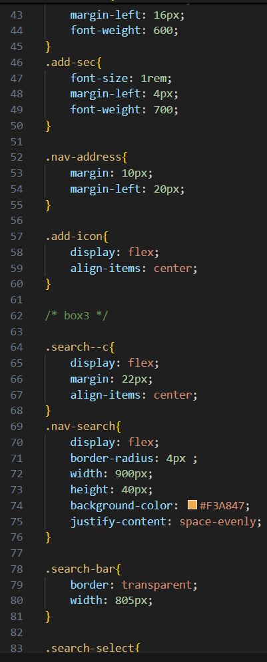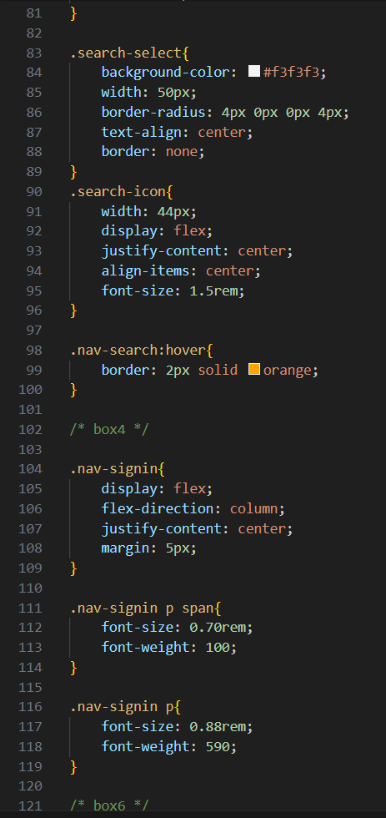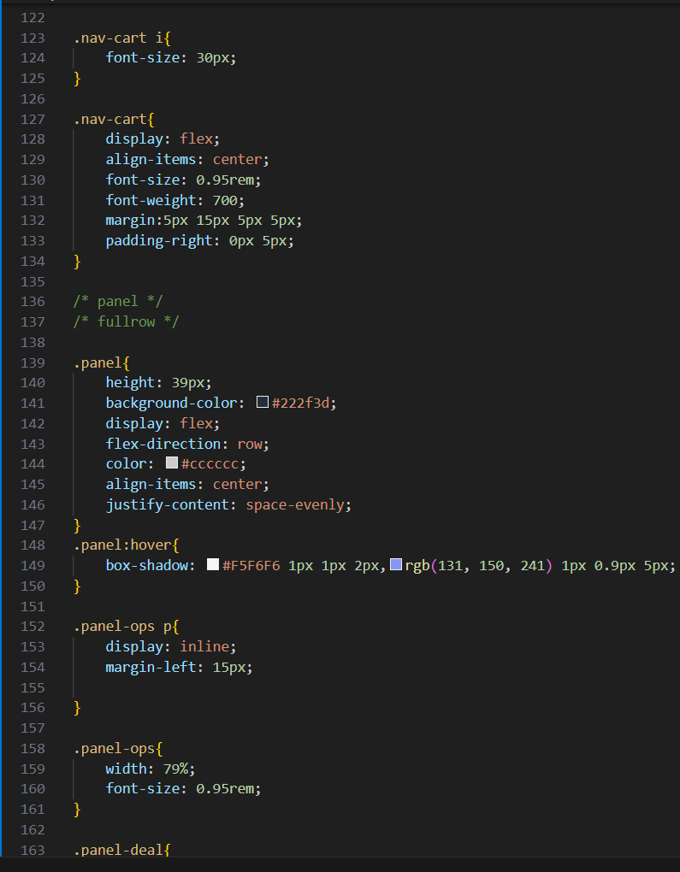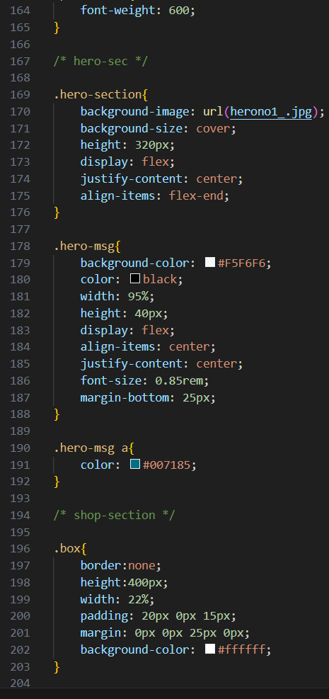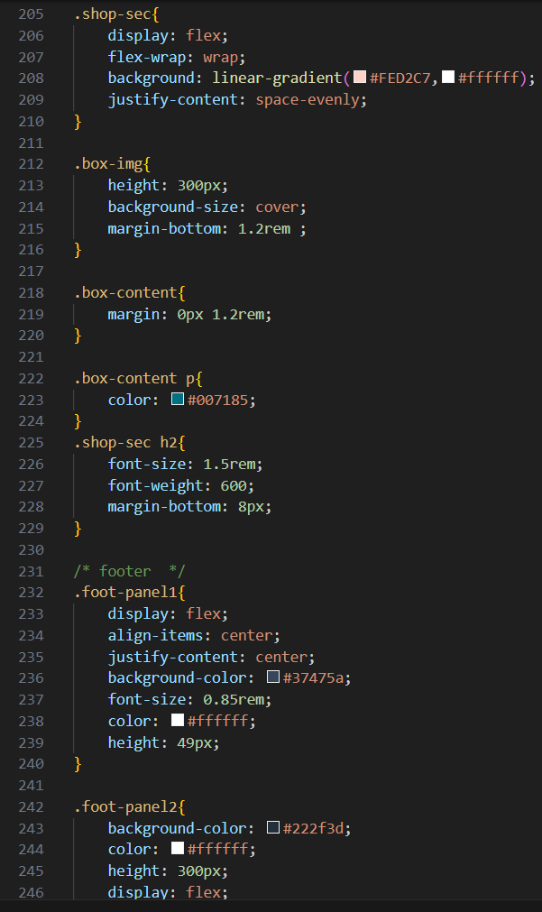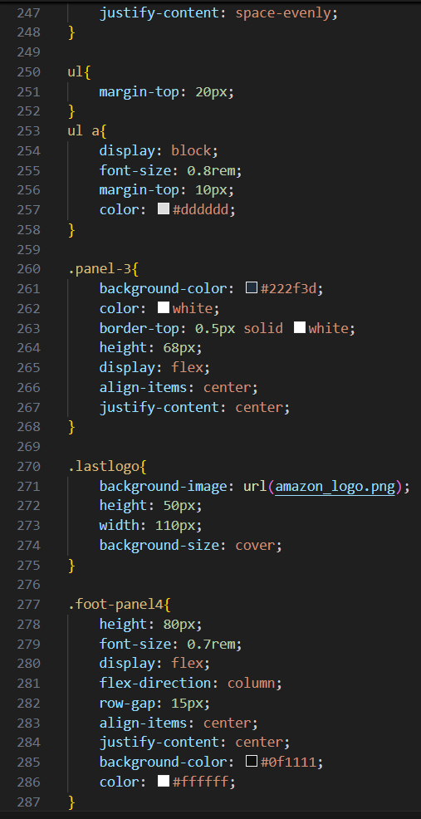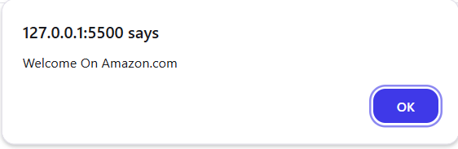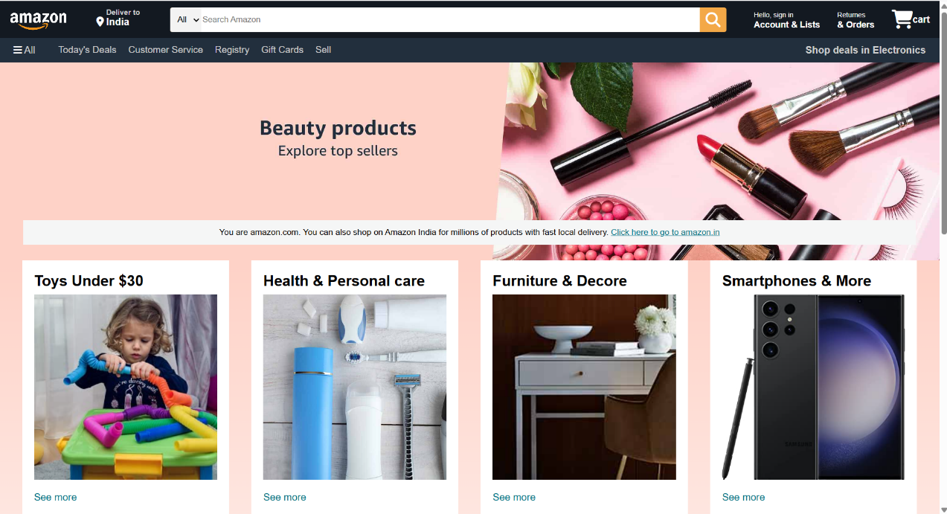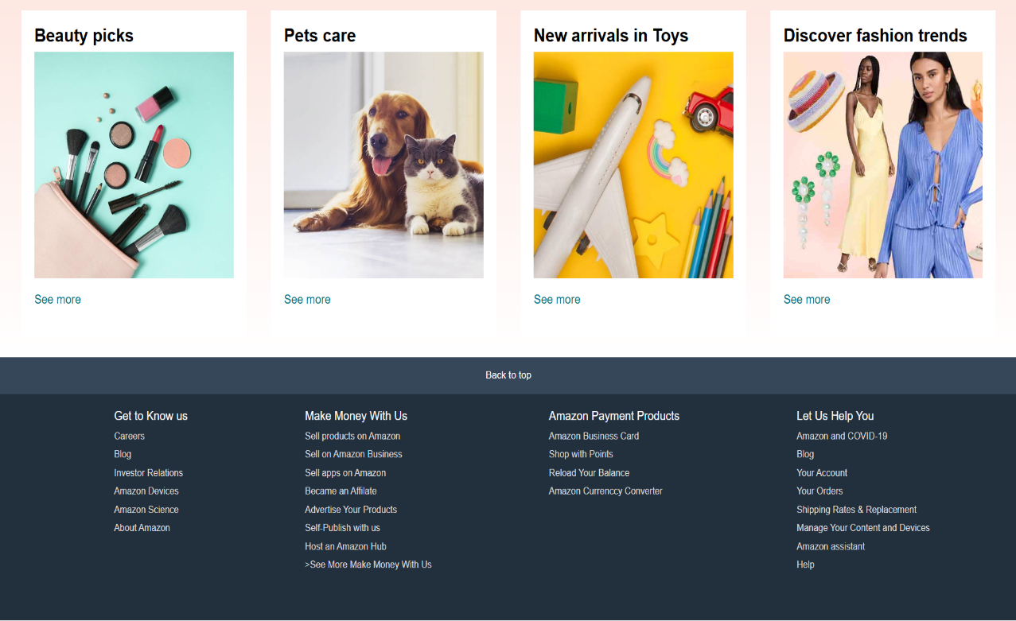

**Project Features:**

* A responsive and structured header with logo, search bar, and navigation menu.
* Product cards displaying product images, titles, prices, and ratings.
* Interactive carousel/slider showcasing promotional banners.
* Responsive grid layout for product listings.
* Functional footer with useful links and information.
* Basic JavaScript-based features like hover effects, menu toggling, and dynamic content updates.

**Development Process:**

1. **Planning:** Analyzed the structure of Amazon's UI to define the project scope and key sections to implement.
2. **Design:** Created wireframes and layout structure using HTML.
3. **Styling:** Applied CSS for layout positioning, styling elements, and ensuring mobile responsiveness.
4. **Interactivity:** Integrated JavaScript to add user interactions and dynamic behavior.
5. **Testing:** Tested the website across different devices and screen sizes to ensure responsiveness and performance.
6. **Optimization:** Optimized code structure and design for better readability and efficiency.

**Conclusion:** The Amazon Clone Web Design Project served as a comprehensive exercise in front-end web development. It helped in understanding the structure and functionality of large-scale websites like Amazon. By completing this project, practical knowledge in HTML, CSS, and JavaScript was solidified, and skills in creating responsive and interactive web pages were enhanced. This clone not only showcases design capabilities but also lays a foundation for future development in full-stack web applications.